Cashew Chicken
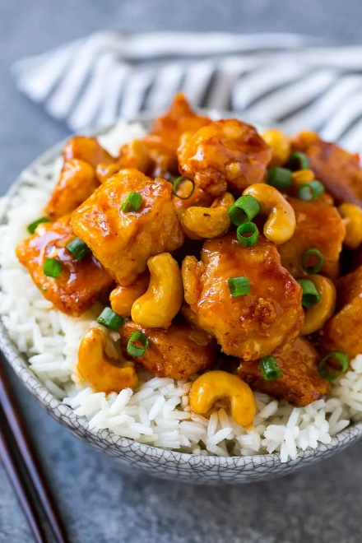
Prep time 25 min Cook time 35 min
4 Servings
Ingredients
1¼ lb boneless skinless chicken breasts
¼ cup + 2 tsp cornstarch, divided
salt and pepper to taste
¼ cup vegetable oil
1 tsp minced ginger
1½ tsp minced garlic
½ cup chicken broth
¼ cup soy sauce
2 tbsp rice vinegar
¼ cup ketchup
2 tbsp sweet chili sauce
2 tsp brown sugar
½ cup roasted cashews
3 tbsp sliced green onions
Directions
- Cut chicken into 1 inch cubes. Place in a bowl with ¼ cup cornstarch and salt and pepper. Toss to coat chicken evenly.
- Heat the vegetable oil in a large pan over medium high heat. Cook chicken for 3 to 4 minutes per side or until browned and cooked through. Transfer to a plate and keep warm.
- Drain any excess oil, leaving 1 teaspoon in the pan. Add the garlic and ginger and cook for 30 seconds.
- In a bowl, whisk together the chicken broth, soy sauce, rice vinegar, ketchup, sweet chili sauce and brown sugar. Pour the sauce mixture into the pan. Bring the sauce to a simmer.
- In a small bowl, add the cornstarch and 2 tablespoons of cold water and whisk to combine. Pour into the pan and bring to a boil. Cook for 1 minute or until sauce has just thickened.
- Place the chicken and cashews in the pan and toss to coat with the sauce. Sprinkle with green onions and serve.
Notes
Double the sauce if serving over rice.

